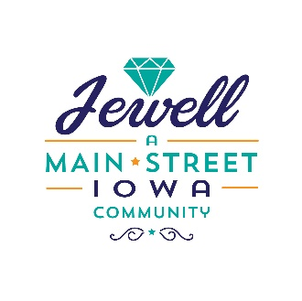
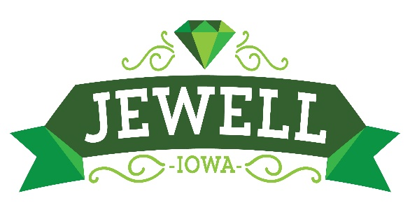

Jewell Jubilee
2021 Parade Application

Jewell A Main Street Community invites you help us celebrate our annual Jewell Jubilee Parade on June 12th, 2021 at 10:00 am. Please complete the application and return by June 7th, 2021.

Organization/Business Group:________________________________________
Contact Petrson:__________________________________________________
Address:________________________________________________________
_______________________________________________________
Day Phone: ( _____ ) ______-__________

Brief Description of Entry: ______________________________________________

*Please arrive and no later than 9:30am the day of the parade
*Position in parade will be determined by your time of arrival
*Horse entries will be at end of parade unless you have someone following to clean up droppings
If you have questions, please call: (515)291-8954 Rick Knoll
Please return to: Rick Knoll
Box 158
Jewell IA 50130
Or email to rickknoll54@gmail.com

